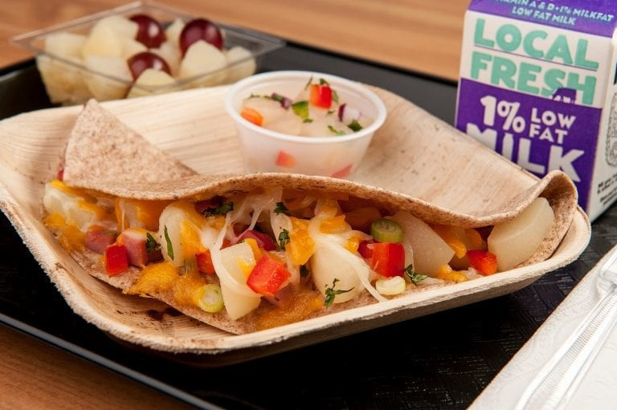

**RECIPE NOTES**

*We recommend using only U.S. grown and canned pears for the best flavor, quality, texture and yield. CCP: No bare hand contact with ready to eat food.

CCP: Hold at 41° F or lower.

Serving: 1/4 cup of pear salsa

**Crediting: 3/8 c fruit.**

FOR THE SALSA:

1. CCP: No bare hand contact with ready to eat food. Drain pears and add to a large mixing bowl.
2. Rinse bell peppers and onions under running water. Dice into ¼” pieces. Add to mixing bowl.
3. Rinse cilantro under running water and dry well using a disposable towel. Chop fine. Add to mixing bowl.
4. Rinse jalapenos. Cut jalapenos into quarters and remove seeds with spoon or knife. Cut into 1/8” dices. Add to mixing bowl.
5. Add lime juice to mixing bowl. Using a spoon, mix to combine all ingredients.
6. Using a no. 16 disher, serve 1/4 cup of pear salsa.

**PEAR SALSA**

33 SERVINGS

**INGREDIENTS**

1 #10 can Pears, pacific northwest, canned, diced, extra light syrup, drained

1 pound 2 ounces Bell pepper, red, diced, EP

**INSTRUCTIONS**

1. Drain pears. Place pears in large mixing bowl. Note: Best to drain pears overnight to remove maximum amount of liquid.
2. Rinse bell peppers under running water. Dice into ½” pieces. Add to mixing bowl.

1 ounce Onions, green, fresh, sliced3. Rinse green onions under running water. Finely slice. Add to mixing bowl.

1 cup Cilantro, fresh, chopped

1 tablespoon Chipotle peppers in adobe sauce, 7 oz can

1. Rinse cilantro under running water and dry well using a disposable towel. Chop fine. Add to mixing bowl.

5Remove chipotle peppers from can and finely chop. Add to mixing bowl.

2 of 2